PERSONAL INFORMATION | Ivan Basamakov
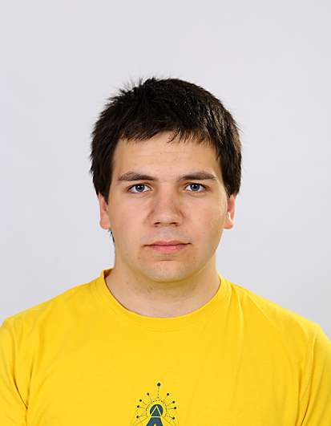 |   Knyaz Alexander Batenberg, 6003 Stara Zagora (Bulgaria)
 |  (+359) 88 574 1630

vanko.petkof@gmail.com
 | Sex Male | Date of birth 29/01/2001 | Nationality Bulgarian

WORK EXPERIENCE

06/2020-Ongoing | Junior DevOps
06/2020-Ongoing | SmartCode
06/2020-Ongoing | Main responsibilities:  - Deploy, monitor and troubleshoot micro-service containers  - Manage and monitor Linux(Debian) hosts

EDUCATION AND TRAINING

Ongoing  10/2020–07/2024 | Bachelor of Information Systems
Ongoing  10/2020–07/2024 | Sofia University "St. Kliment Ohridski", Sofia(Bulgaria)
09/2015–05/2020 | High School Diploma in Informatics
09/2015–05/2020 | PPMG "Geo Milev", Stara Zagora (Bulgaria)

PERSONAL SKILLS

Professional skills | - Good knowledge of Linux (self-taught and gained through work as DevOps)  - Bash  - iptables  - various other command-line tools  - Good knowledge of Automation using Terraform and Ansible (gained through work as DevOps)  - Basic knowledge of Golang (gained through work as DevOps)  - Good understanding of containerisation and Dokcer (gained through work as DevOps)  - Intermediate knowledge of C++ (gained through participating in national and international  competitions)  - Understanding of computer networks (self-taught and gained through work as DevOps)  - Basic undrestanding of network hardware (self-taught and gained through work as DevOps)  - Proficient knowledge of computer hardware (self-taught during my time as content creator for a  technology website)

Native language | Bulgarian
Foreign language | UNDERSTANDING |  | SPEAKING |  | WRITING
Foreign language | Listening | Reading | Spoken interaction | Spoken production
English | C2 | C1 | C1 | C1 | C1
Communication skills | - Good communication skills gained through my experience as president of the student's council

Organisational / managerial skills | - Good team-leading skills gained through my experience as president of the student's council

Driving licence | B

ADDITIONAL INFORMATION | - Volunteering as part of the AV team at OpenFest (Sofia, Bulgaria) since 2019  - Volunteered as part of the AV/Streaming team at FOSDEM 2020 (Brussels, Belgium)  - Very active and outgoing person  - Always excited about new opportunities and challenges  - Has passion for books and producing music  - Interested in Aviation and Automobilism

